Evacuation Accounts
Friday 1st September 1939 saw the beginning of ‘Operation Pied Piper’ – the mass movement of British children out of large cities and towns to places considered to be safer, usually in the countryside. Over three days, 1.5 million children were moved from their homes to more rural locations.
Evacuation was voluntary, but the fear of bombing, the closure of many urban schools and the organised transportation of school groups helped persuade families to send their children away to live with strangers.
Evacuees and their hosts were often astonished to see how each other lived. Some evacuees flourished in their new surroundings. Others endured a miserable time away from home. Many evacuees from inner-city areas had never seen farm animals before or eaten vegetables. In many instances a child's upbringing in urban poverty was misinterpreted as parental neglect. Equally, some city dwellers were bored by the countryside, or were even used for tiring agricultural work.

What follows are 6 brief accounts from people who were evacuated away from their homes at the start of the war.

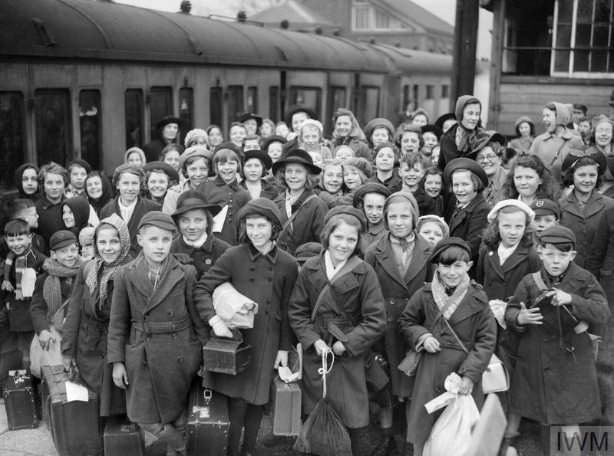

Account 1
I was billeted with a lady called Ms Reeds, who lived in a large house together with her maid Bertha. She was a maiden lady and had no idea how to look after children. The lady loved books and her house was like a library, in fact, there was one, so I was in my element. We used to eat in great style and there was never a truer expression, all style, and no substance. The food was served by Bertha offering us the food covered by a silver tureen. But underneath would be a measly scrap of meat, or a horrible sausage, with lots of potatoes. I used to help Bertha clean the silver after school, and then I would listen to children's hour on the radio, just for one hour, then I would read and read. Remember, no television, and there were no washing machines. Ms Reeds employed a washing woman to do that, and it was my job to take the bundles of washing down to her, and her son, Roy, would bring the washing back. I was around 9 then, and I think I was in love with Roy. Of course, the war was going full-blast by then, the sirens would wail and we would have to go into these awful Anderson shelters in the garden. Cold and damp and horrible, sometimes we would have to sleep in them with itchy blankets and plenty of spiders. I was always being told 'Stop fidgeting Suzanne'.
-Sue Korson

Account 2
‘I was separated from my mum and dad the day we got on the boat to be evacuated to the island of Guernsey. We didn’t realise then what was happening. My mum didn’t have any money to come across town to wave us off or maybe she didn’t come because it was too distressing. When I was evacuated it seemed a long long time in my mind since I had not seen my mum and dad.
I started to forget what my mum’s face looked like, it was such a long time since I saw her.
I went to one or two horrible places. The first place I went to, she gave me some wool and I gave my friend two or three little balls of wool because she gave it to me and she could see I was knitting. I liked knitting. I thought she gave it to me for me. But when she found out I’d given my friend two or three little balls she hit the roof, as if I’d stolen it. So then I had to move to another house so we went to the billeting officers place which was like lots of rooms where you go while they wait to find you a place.’
- Betty

Account 3
‘I was only five when the war broke out. We lived in a flat in Lambeth at the time. The block we were in had its own shelter. It was in the basement under the ground floor. The air raid shelters had quite a community spirit. We had parties down there and there was plenty of singing. The kids really enjoyed themselves. At that age it was all a game. I was eventually evacuated. I remember going to the station and there were literally hundreds of children lined up waiting to go. Everyone had a cardboard box with their gas masks in and a label tied to their coats to identify them if they got lost. We ended up in South Wales. The first night we slept on the floor of the church hall. The next day my sister and I were allocated to a Mr and Mrs Reece. At first it was quite frightening being separated from your mother and not understanding what was going on. However, after a few days we settled down and quite enjoyed being in Wales. After living in London we were now surrounded by countryside. The village we lived in was very small. There were mines close by and we had great fun exploring the slag heaps. My sister and I got on very well with Mr and Mrs Reece. We never saw them as parents. We knew it was only a temporary situation
We were in Wales for about two and a half years. I got my love of the country from this time – it was the first time I had ever lived in the country and I was very well fed. We had plenty of eggs, butter and milk and I used to go round farms and collect these. ‘
- Keith

Account 4
I arrived in Cowling on September 3rd 1939, yes I was an evacuee. I came with my two younger brothers and with other children from St.Augustine’s School. We all had our gas masks in the card board box what was issued some time before we were evacuated. The bus took us to the village hall and there we were given families to stay with. I was taken to Stott Hill Farm to stay with Annie and Jonas Stephenson. My two brothers stayed across the road at the farm.
My first look at the countryside was the next day Sunday 4th Sept, what a step to take at 13 years old to leave my parents. I went out into the farmyard and what a sight hens and chickens, cows and horses something I had not been so close to before.
I remember going to the village school with the girls and my brothers it was a very friendly school. I learned how to weave wickerwork and I made a sewing basket for my mother lined out in green.
The great snow came 39/40 winter and I remember the roads being blocked. I could not see out of my bedroom window for quite a while, we had to be dug out the snow was very deep, I was given my first pair of clogs and as I walked to school I got taller and taller the snow packed between the clog irons, I found the clogs very comfortable to wear and even brought them home when I started work at 14. I had some lovely times there.
I remember walking up Bobbits Hill and through the fields to the pinnacle and coming back gathering watercress from the stream I remember seeing in the first few days a white calf just born a miracle of new life to a city girl like me. I do hope some of my memories have been helpful. They are all my treasured memories.
- Dorothy Colyer
Account 5
When we came back from holiday we found that my school, a junior school, had been closed completely, evacuated. We didn’t know what was in store. We didn’t know if we would get bombed immediately. We just didn’t know what to expect at all. My godmother had a car and took me immediately to Broadway in Gloucestershire where my grand parents lived. I went there for two months but after two months nothing had happened so my school opened again and I came back. The bombing didn’t start until the Summer of 1940 but then it really started. There were so many bombs and we would eat so many of our dinners in the Anderson shelter. I began to get quite nervous so my cousin, who I had never met, said ‘What about sending Margaret out to me in the country?’ She lived in Shropshire. So my parents consulted me and asked me if I wanted to go there and I didn’t really want to but there didn’t seem to be any option but to get me away from it. I can remember the date now, December the 4th 1940. My mother took me by train. It took nearly all day. I went to this cottage and my mother stayed the night and I me this aunty Hilda who was the head of girls high school there. She took me in and I went to that school and I stayed there for six years until I had done my, what would now be , GCSEs. But apparently when I went on 4th December 1940 I was in such a state that first night they had to keep going in during the night and putting my bed covers on me. I don’t remember being in that state but I do remember going there and the thing that I think is so dreadful that people wouldn’t understand now is that I had no communication with my parents or anyone from my family for 32 weeks, which is pretty horrific for a child of ten. The only thing I knew was the news. There had been a raid on a west midland town which meant Birmingham, Wolverhampton or Coventry. On the news they never said the actual place and I had a letter once a week form my mother. So you can imagine life was a bit grim. My childhood had come to an end. I’d gone to a strange place, knew nobody, went to a strange school and got a new school uniform but I felt horribly out of place there. I don’t have happy memories of the war. I was allowed back for the summer holidays as the war had lapsed a bit and it was considered safe for me to come but how I cried and cried and cried at going back. I didn’t want to eat.
- Margaret Hudson

Account 6
My primary school in Bootle, near Liverpool, evacuated their children to Southport on 1 September 1939. Mothers and very young children were to follow the next day. We were told it was to be a practice run. Being an adventurous child I thought it quite exciting but my younger brother cried so much we missed the bus on 1 September and had to go with the mothers and babies.
When our bus arrived at Holy Trinity Church Primary School in Southport a crowd of would-be billet mothers were waiting by the gate. We had to run the gauntlet to get into the schoolyard and as I dragged my reluctant brother by the hand I heard a lady remark, 'I like the look of that one — the girl.' I remember feeling strong resentment at the slur on my brother and the cattle-market atmosphere. A billeting officer walked the two of us to a house nearby and rang the doorbell. There was no reply and she surmised that the people were at work so told us to wait on the doorstep until they returned home and then to explain who we were.
War was declared the next day so we did not go home as we'd expected. There were only two adults in our house and I remember very little about them. We were left very much to ourselves. I had to help my brother get ready for school every day. I started walking in my sleep and occasionally dreamed that I had gone to the bathroom only to wake up as I wet the bed.
After about a month the couple moved to Bolton and we were duly delivered to another couple who lived in a flat over their butcher’s shop. They had a new baby and I soon learned how to warm his milk and enjoyed singing him to sleep. They took us into their home without any fuss and life became a routine of school, pushing the pram on the promenade and stews with cow heel almost every day for dinner. We had never eaten it before and certainly never since but at least we were never hungry, one of the bonuses of living over a butcher’s shop in wartime, I suppose. One of the drawbacks was that it was my daily chore to empty the mouse- trap that was laid every evening on the stairs down to the shop.
- Lily Hoskins

