Q1.

The shaded shape is a square.
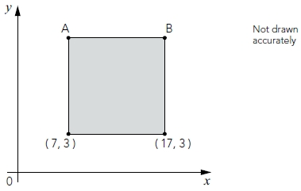
What are the coordinates of A and B?
1 mark
1 mark
Q2.
On the grid there are three points joined by two lines.
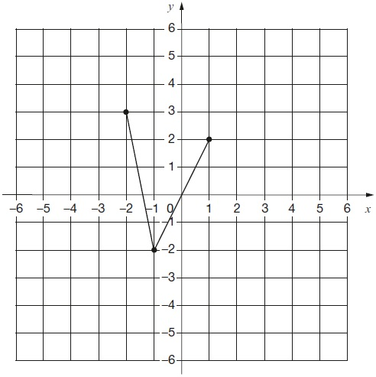
Lara plots another point on the grid at (−1, 2).
She joins the points to make a quadrilateral.
Complete Lara’s quadrilateral on the grid.
Use a ruler.
1 mark
Then Lara translates the quadrilateral 4 squares to the right.
Draw the quadrilateral in its new position on the grid.
1 mark
Q3.
ABDE is a rectangle on coordinate axes.
The sides of the rectangle are parallel to the axes.
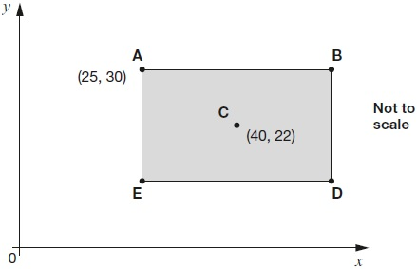
Point C is the centre of the rectangle.
What are the coordinates of B and D?

B is
D is
2 marks
Q4.

Here are two identical shaded triangles on coordinate axes.

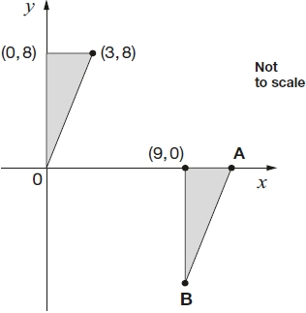
Write the coordinates of points A and B.

A =
B =
2 marks
Q5.

This diagram shows two identical rectangles on coordinate axes.
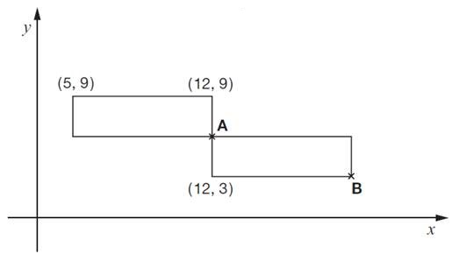
Write the coordinates of point A and point B.
1 mark
1 mark
Q6.

Here is a square on coordinate axes.
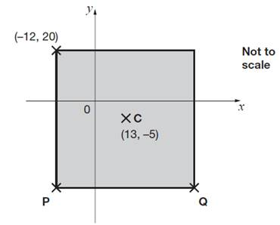
C is the centre of the square.
Find the coordinates of P and Q.
1 mark
1 mark
Q7.

The diagram shows three identical shaded triangles on coordinate axes.

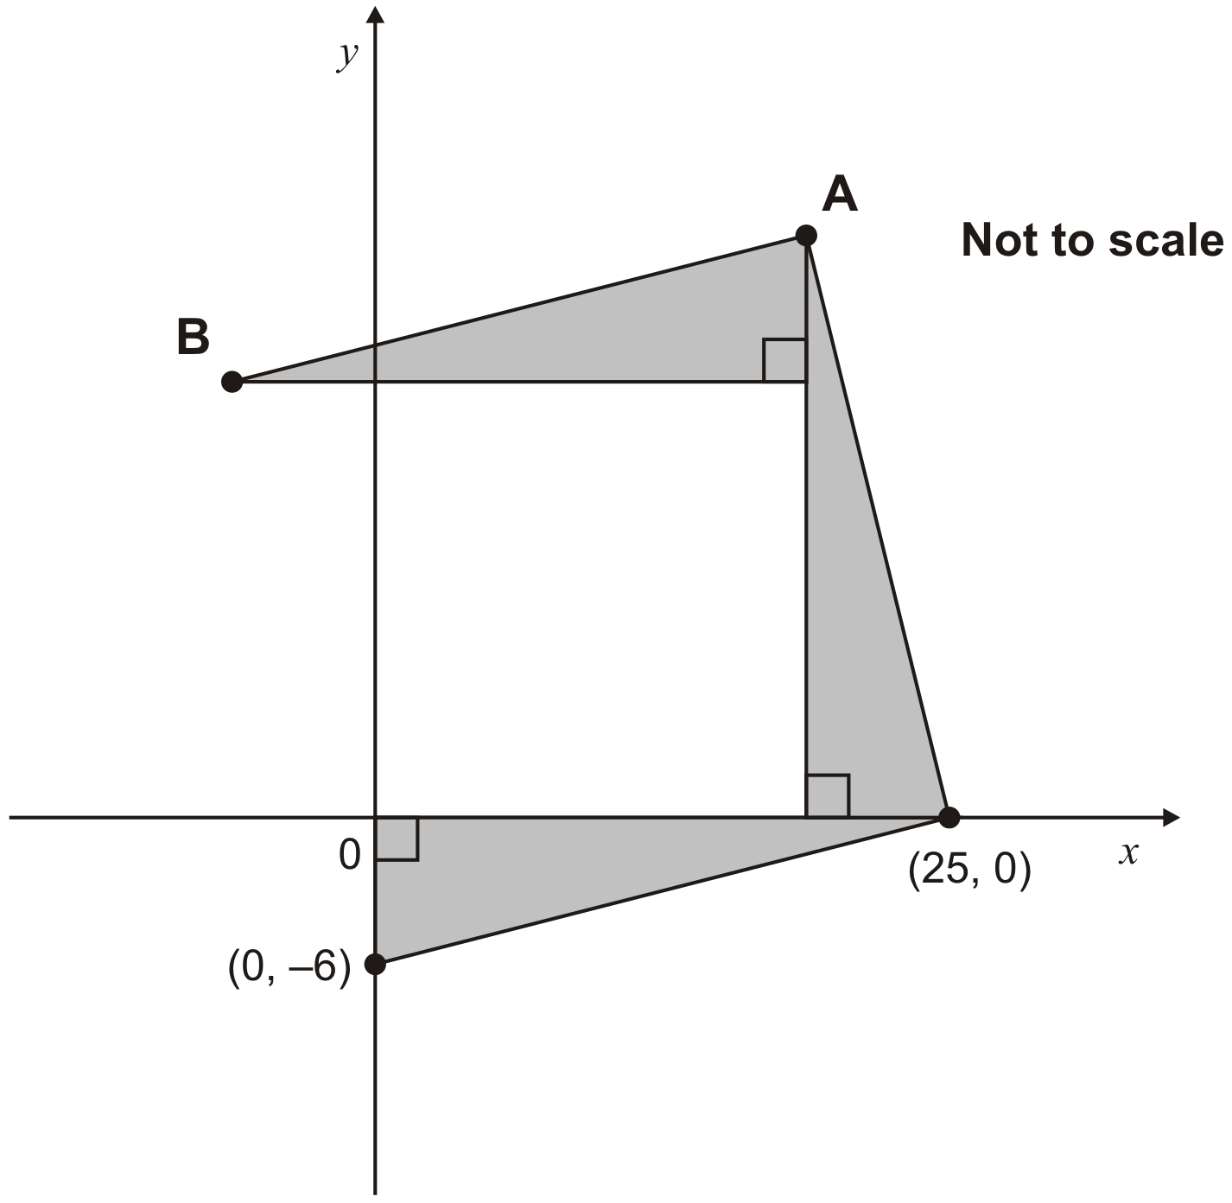
What are the coordinates of A and B?
1 mark
1 mark
Q8.

A and B are joined by a straight line on coordinate axes.

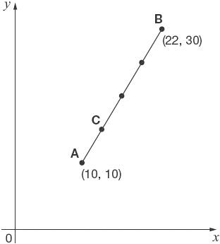
The dots on the line are equally spaced.
What are the coordinates of C?
2 marks
Q9.

Here is a shaded square on x and y axes.

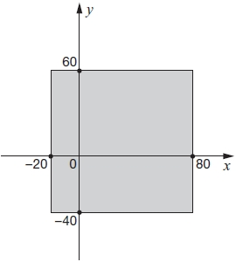
For each of these points, put a tick (✔) to show if it is inside the square or outside the square.

 | inside  the square | outside  the square
(50, 70)
(60, –30)
(–10, 50)
(–30, –30)
2 marks
Q10.

The diagram shows 6 shaded squares.
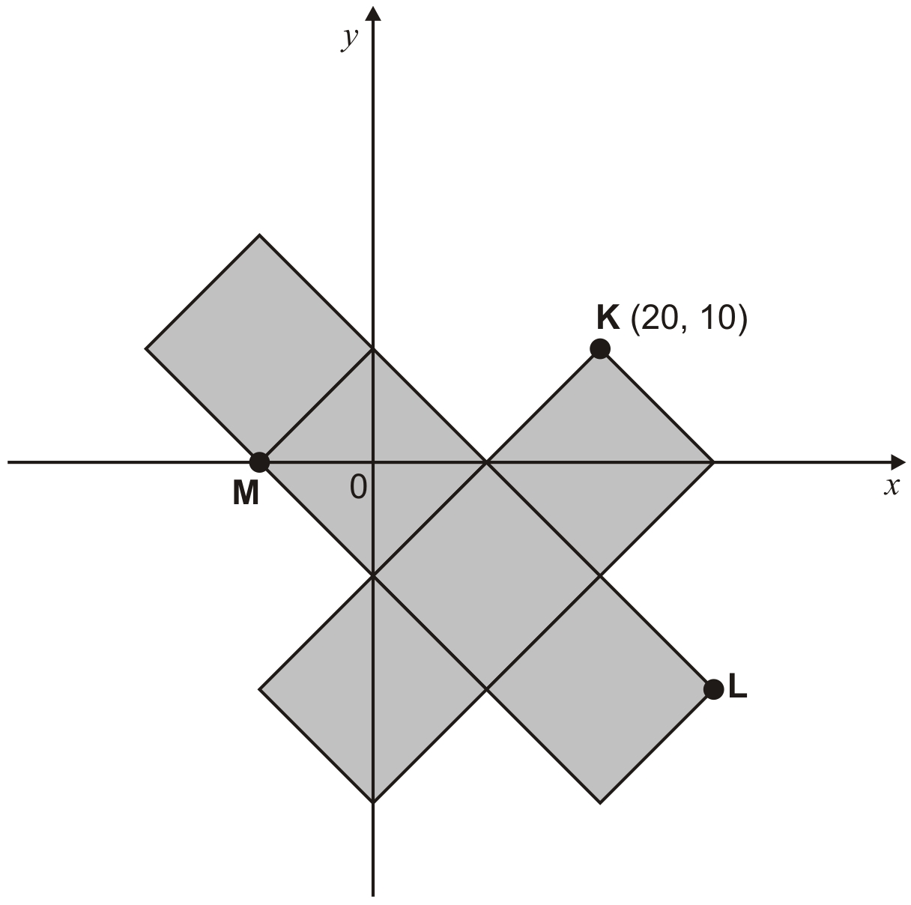
K is the point (20, 10)
What are the coordinates of L and M?

L is
1 mark

M is
1 mark
Q11.

Here is a design on a square grid.
Complete the design so that it is symmetrical about the mirror line.
Use a ruler.
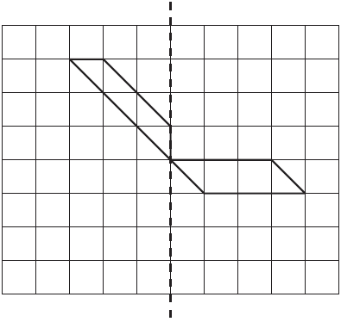
mirror line
1 mark
Q12.

Shade two squares and one triangle to make this design symmetrical about the mirror line.
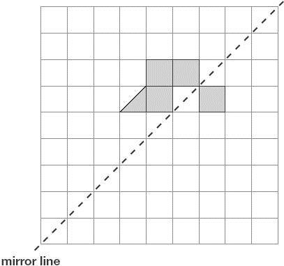
1 mark
Q13.
Here is a shaded shape on a square grid.
Reflect the shape in the mirror line.
Use a ruler.
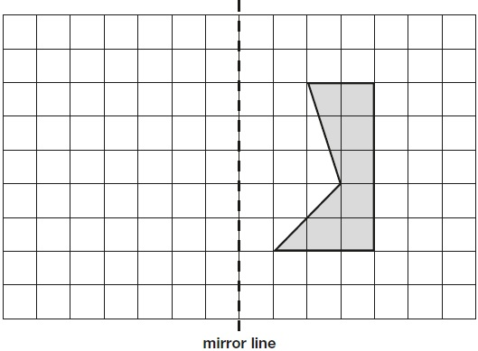
1 mark

Q14.

Draw the reflection of the shaded triangle in the mirror line.

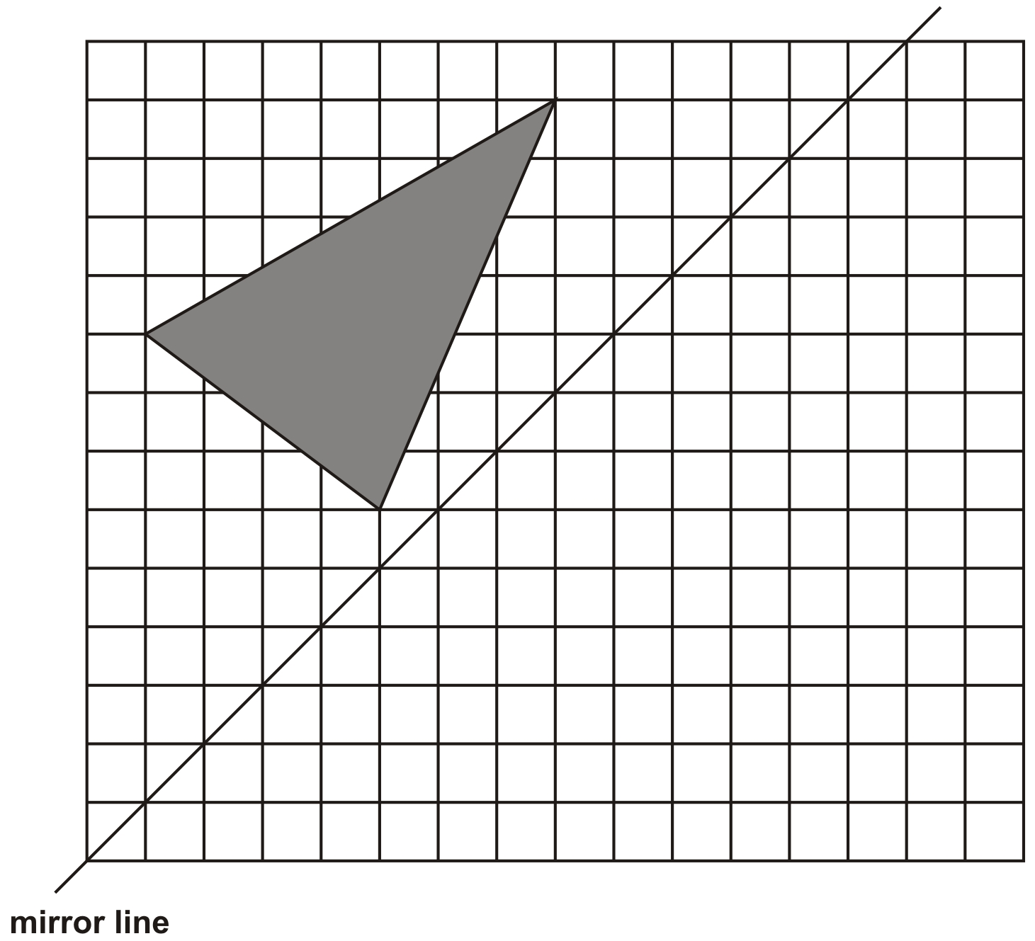
2 marks
Q15.

The diagram shows the triangle ABC and the line y = x.
Draw the triangle PQR which is the reflection of the triangle ABC in the line y = x.

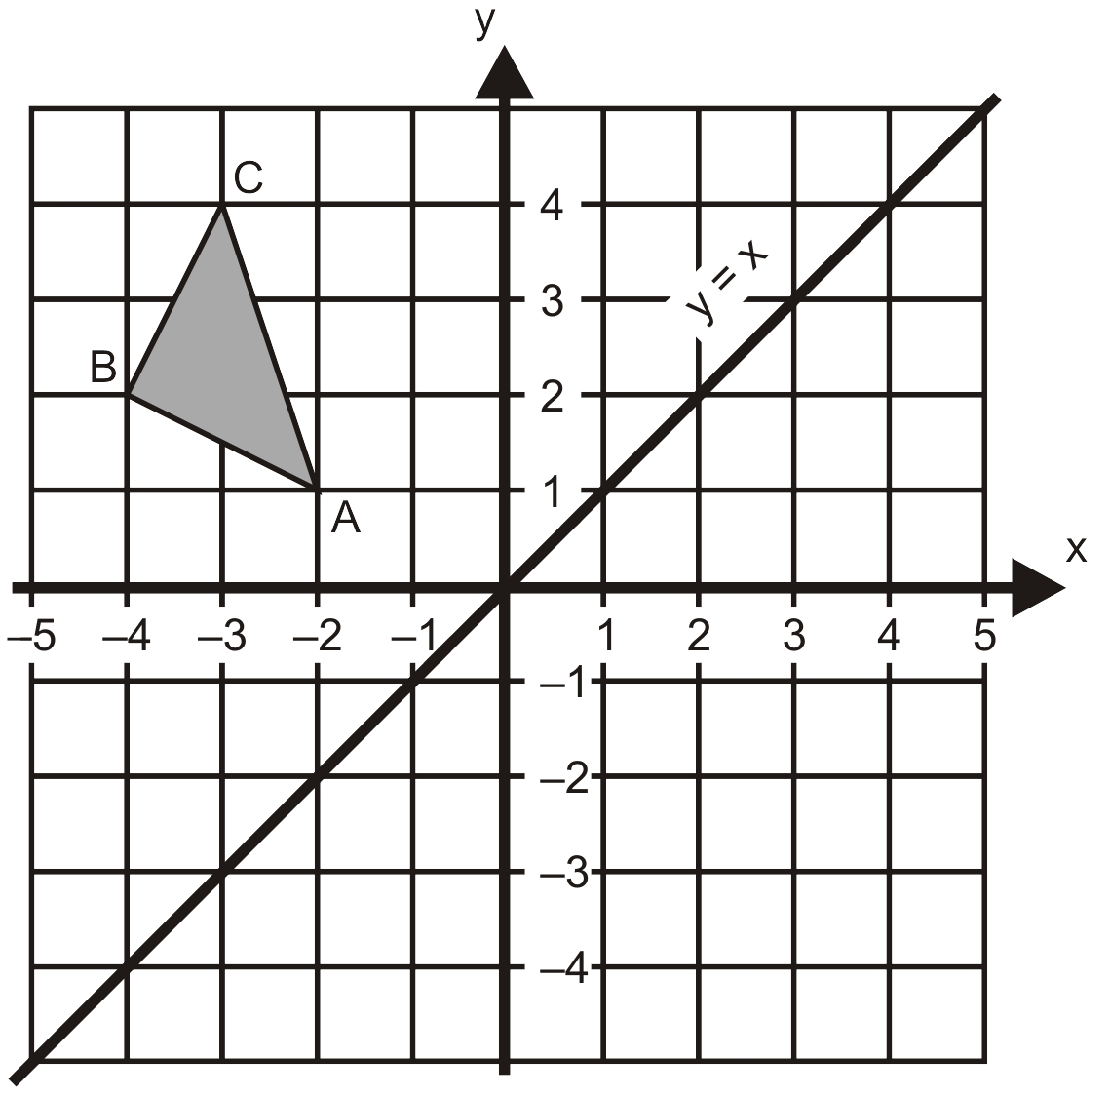
2 marks

Q16.

Here is a quadrilateral on a square grid.
The quadrilateral is translated so that point A moves to point B.
Draw the quadrilateral in its new position.
Use a ruler.
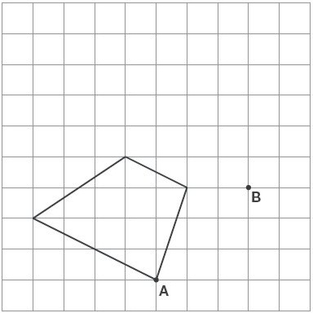
1 mark
Q17.

Here is a triangle on a square grid.
The triangle is translated so that point A moves to point B.
Draw the triangle in its new position.
Use a ruler.

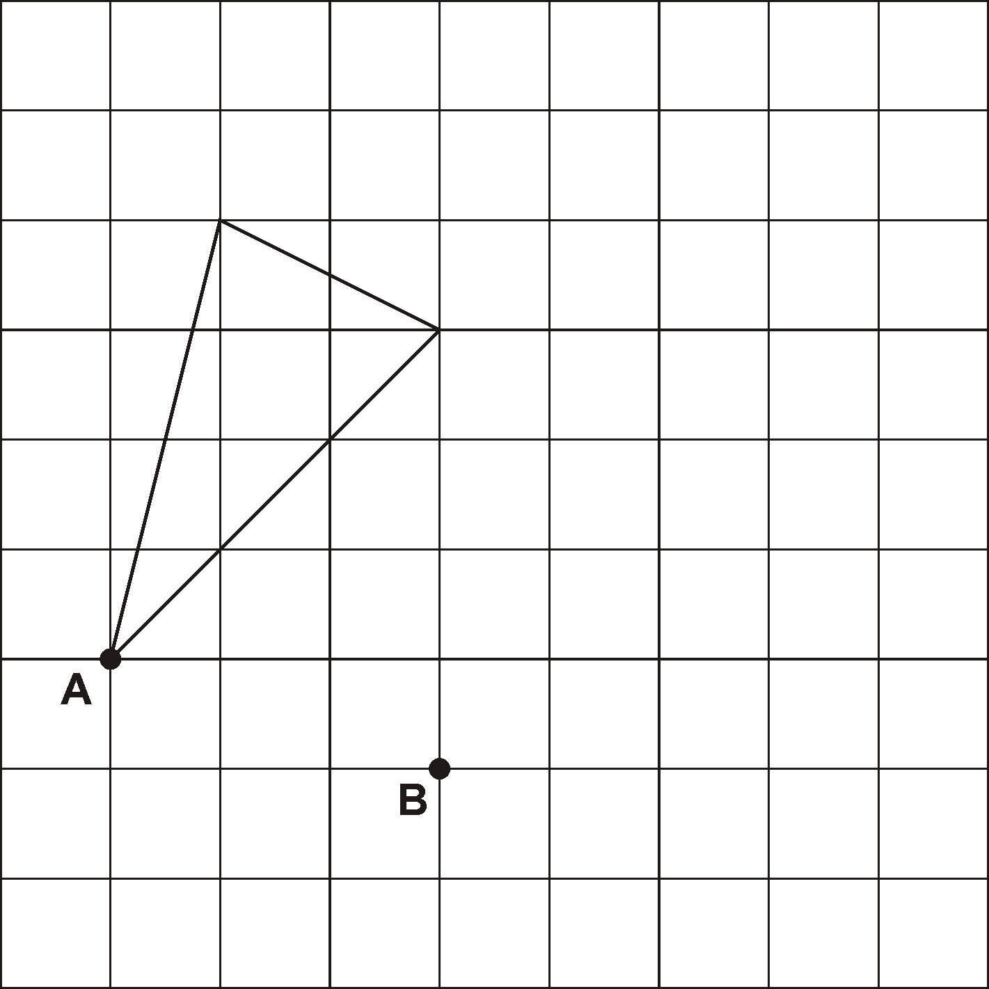
1 mark

Q18.

Here is a triangle drawn on a coordinate grid.
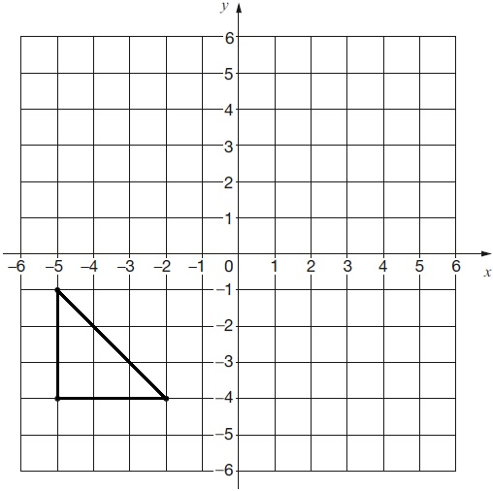
The triangle is translated 7 right and 5 up.
Draw the triangle in its new position.
1 mark
Q19.
Here is a shape on a grid.
The shape is translated so that point A moves to (7, 8).
Draw the shape in its new position.
Use a ruler.
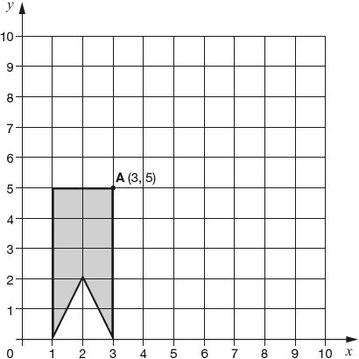
1 mark
Q20.

Here are some tiles on a square grid.

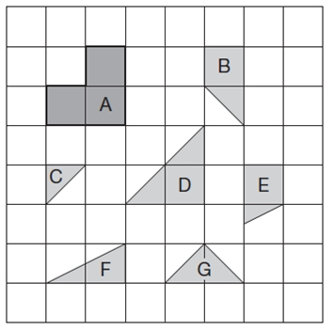
Three different tiles can be fitted together without overlapping to make a shape identical to tile A.
Write the letters of the three tiles.

_______________ and _______________ and _______________
1 mark

Mark schemes
Q1.
Indicates correct coordinates for both points, ie A as (7, 13) and B as (17, 13)
2
or
Indicates correct coordinates for one point
or
Transposes the responses, ie A as (17, 13) and B as (7, 13)
or
The only error is to indicate incorrect, but consistent, y ordinates, provided y > 3
eg
• A as (7, 12) and B as (17, 12)
1
U2
[2]

Q2.
(a) Quadrilateral completed, as shown:
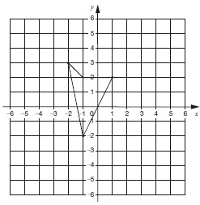
Accept slight inaccuracies in drawing provided the intention is clear.
1
(b) Quadrilateral translated correctly, as shown:
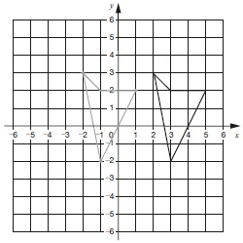
Accept slight inaccuracies in drawing provided the intention is clear.
Award ONE mark if the answer to (b) is a quadrilateral with sides drawn and is a correct translation of their answer to (a).
1
[2]
Q3.
(a) Award ONE mark for B is (55, 30)
1
(b) Award ONE mark for D is (55, 14)
If B and D are incorrect, ONE mark may be given for the correct y coordinate for both B and D and the same x coordinate (incorrect) for both points, i.e.
• D is (same x as B, 14)
1
[2]
Q4.
(a) (12, 0)
Accept unambiguous answers written on the diagram.
1
(b) (9, –8)
If the answer to (a) is (9, –8) AND the answer to
(b) is (12, 0) then award ONE mark for (b).
1
[2]
Q5.
(a) A is (12, 6)
1
(b) B is (19, 3)
1
Coordinates must be given in the correct order.
If the answer to (a) is (19, 3) AND the answer to
(b) is (12, 6) then award ONE mark for (b)
Accept unambiguous answers written on the diagram.
[2]

Q6.
(a) P is (−12, −30)
! Coordinates
Accept unambiguous answers written on the diagram
1
(b) Q is (38, −30)
! Answers for P and Q transposed
Award 1 mark for Q only, ie:
• P is (38, –30)
Q is (–12, –30)
! Answer for Q correctly follows through from an incorrect answer for P
Award 1m for Q for follow-through from P as
(‘their x’ + 50, ‘their y’)
1
[2]

Q7.
(a) (19, 25)
! Coordinates
1
(b) (–6, 19)
! Gives values for A and B transposed
Award 1m for part (b) only, ie:
• A is (–6, 19) and B is (19, 25)
1
[2]
Q8.
(a) 13 for the x coordinate
Accept unambiguous answers written on the diagram.
U1
(b) 15 for the y coordinate
Accept unambiguous answers written on the diagram.
1
If the answer to (a) is 15 AND the answer to (b) is 13, then award ONE mark for (b).
[2]
Q9.
Award TWO marks for four rows ticked correctly, as shown:
If the answer is incorrect, award ONE mark for three rows ticked correctly.
Accept: alternative unambiguous indications such as or Y.
Up to 2
[2]

Q10.
(a) L is (30, –20)
Coordinates must be in the correct order.
1
(b) M is (–10, 0)
Accept answers on the diagram, with or without commas or brackets.
1
[2]
Q11.
Diagram completed as shown:
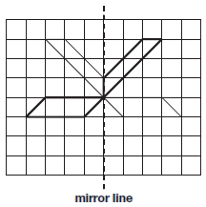
Accept slight inaccuracies in drawing.
[1]
Q12.
Diagram completed as shown:
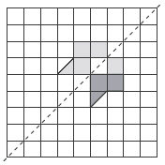
mirror line
Accept inaccurate drawing provided the intention is clear.
[1]
Q13.
Diagram completed, as shown:
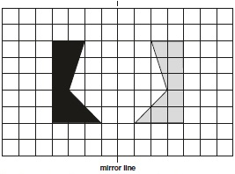
Accept slight inaccuracies in drawing.
Shape need not be shaded for the award of ONE mark.
[1]
Q14.
Award TWO marks for the correct drawing as shown below.
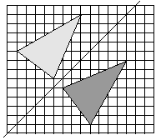
If the triangle is drawn incorrectly, award ONE mark for TWO vertices of the
reflection correctly located on the grid.
If all of the vertices are drawn correctly but the triangle is not drawn or is
incomplete, award ONE mark.
Accept drawing errors of up to 1mm from a correct vertex.
Triangle need not be shaded.
Up to 2
[2]
Q15.
Award TWO marks if all 3 vertices are in the correct positions.
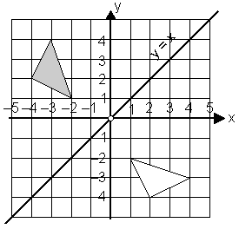
Award ONE mark if only 2 vertices are in the correct positions.
No mark is awarded if 2 or more vertices are incorrectly positioned.
Up to 2
[2]
Q16.
Diagram completed as shown:
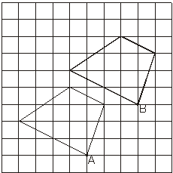
Accept slight inaccuracies in drawing
[1]
Q17.
Diagram completed as shown:
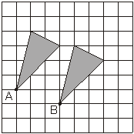
Accept slight inaccuracies in drawing
(see page 3 for guidance).
[1]
Q18.

Triangle with vertices at (2,1) AND (2,4) AND (5,1) drawn on the grid as shown:
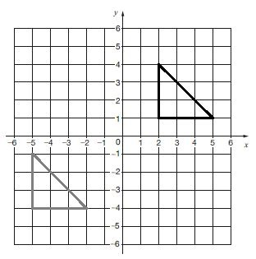
Accept slight inaccuracies in drawing
[1]
Q19.
Shape located correctly, as shown:
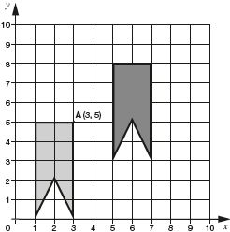
Accept slight inaccuracies in drawing (see guidance).
Shape need not be shaded for the award of ONE mark.
[1]
Q20.
B AND C AND G
Letters may be given in any order.
U1
[1]

