Q1.
Adam has this rectangular piece of card. It is marked with grid lines.
Adam makes two straight cuts along the grid lines.
The two cuts divide the rectangle into 3 shapes:
• 2 squares of different size, and
• 1 rectangle.
Using the grid lines, draw two lines that show where Adam could have made his cuts.
Use a ruler.
1 mark
Q2.

Join dots on the grid to make a quadrilateral that has 3 acute angles.

1 mark
Q3.

Here is a hexagon.
Draw two straight lines across the hexagon to make two triangles and two quadrilaterals.
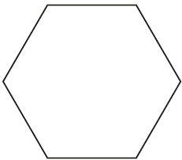
1 mark
Q4.

The following quadrilaterals all have a perimeter of 36 cm.
Here is a table to show the length of each side.

Complete the table.
One quadrilateral is done for you.

 | Side lengths
square | 9 cm 9 cm 9 cm 9 cm
rectangle | 3 cm
rhombus | 9 cm
kite | 10 cm
2 marks

Q5.

Here are six quadrilaterals with their mathematical names.
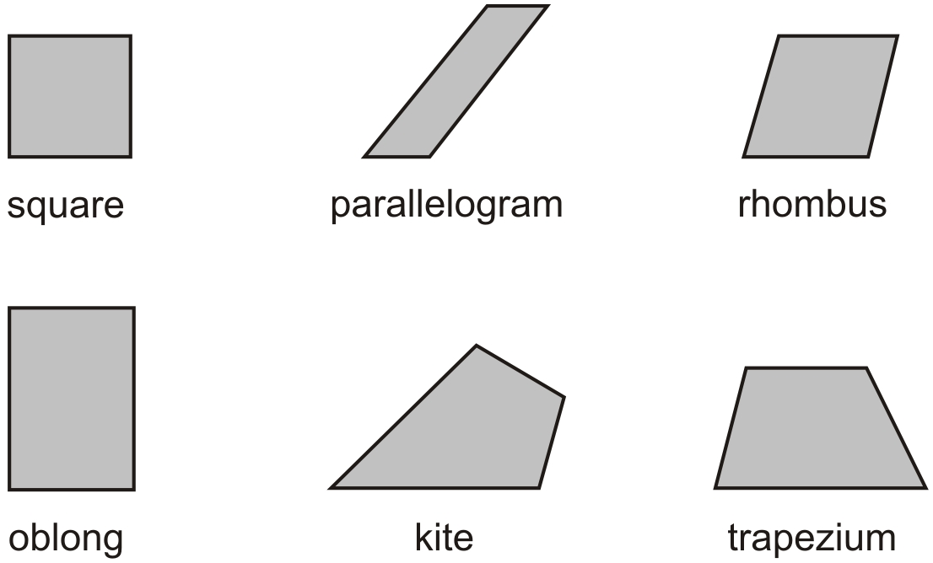
Lara chooses one of the quadrilaterals.
She says,
‘It has two acute angles.
All four sides are the same length’.
Which quadrilateral did Lara choose?
1 mark
Stefan chooses one of the quadrilaterals.
He says,
‘It has more than one obtuse angle.
It has no parallel sides’.
Which quadrilateral did Stefan choose?
1 mark

Q6.

Here is a centimetre grid.
Draw two more lines to make a quadrilateral with an area of 18 cm².
Use a ruler.

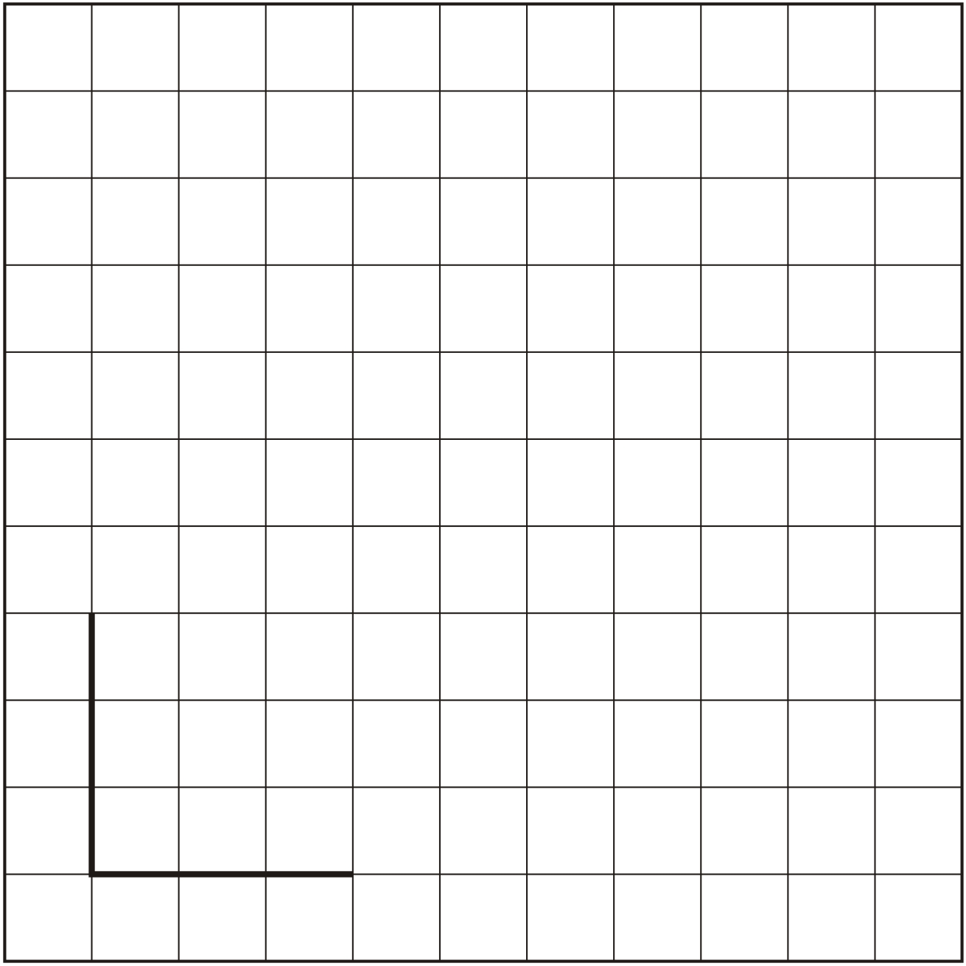
1 mark
Q7.

The diagram shows two overlapping squares and a straight line.

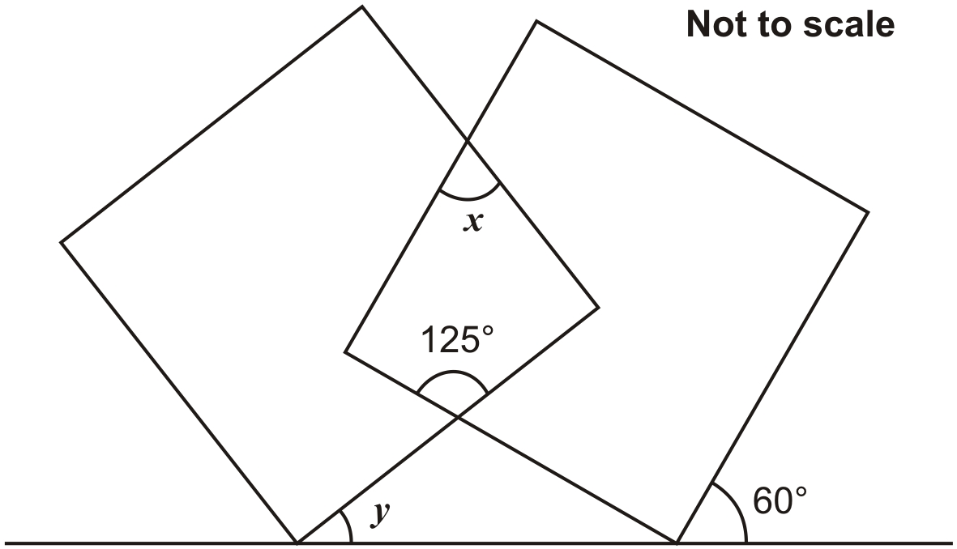
Calculate the value of angle x and the value of angle y.
Do not use a protractor (angle measurer).

1 mark
1 mark
Q8.

Triangle ABC is equilateral.

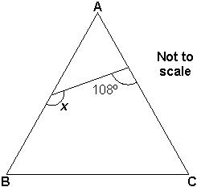
Calculate the size of angle x.
Do not use an angle measurer (protractor).
1 mark
Q9.

The diagram shows a shaded square inside a larger square.

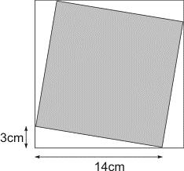
Calculate the area of the larger square.
1 mark
Calculate the area of the shaded square.

2 mark
Q10.

Shapes
Mike has a triangle grid.
He shades in 2 triangles to make a shape with 4 sides.
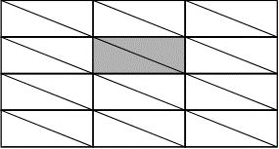
(a) Shade in 2 triangles on this grid to make a different shape with 4 sides.
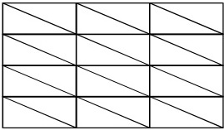
1 mark
(b) Shade in 2 triangles on this grid to make another different shape with 4 sides.
1 mark
(c) Shade in 4 small triangles on this grid to make a bigger triangle.
1 mark
(d) Shade in more than 4 small triangles on this grid to make a bigger triangle.
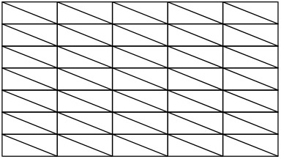
1 mark
Q11.
A circle has a diameter of 22 cm.
What is the length of its radius?
1 mark
Q12.

Four large circles and five small circles fit exactly inside this rectangle.

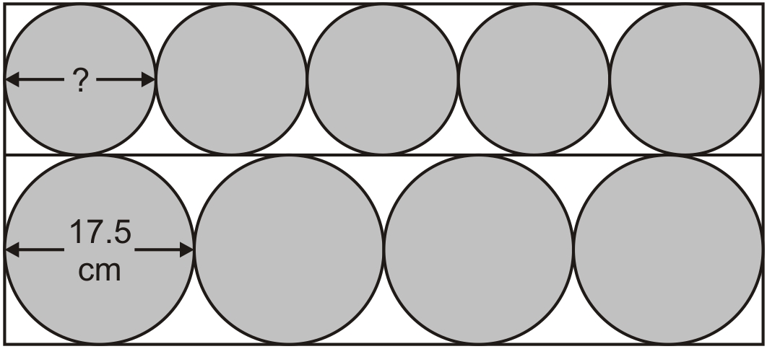
Not actual size
The diameter of a large circle is 17.5 centimetres.
Calculate the diameter of a small circle.

2 marks
Q13.

The diagram shows a right-angled triangle inside a circle.
The circle has a radius of 5 centimetres.

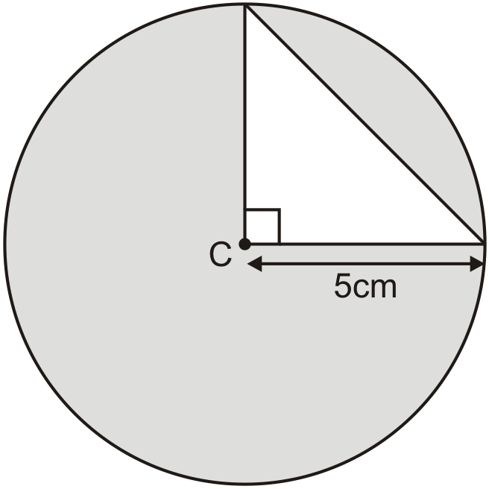
Calculate the area of the triangle.
1 mark
Calculate the area of the shaded part of the diagram.

2 mark
Q14.

The flag of Greenland is a rectangle with a circle drawn inside.

Here is the same flag rotated.

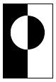
The sketch gives the information you need to draw the flag.

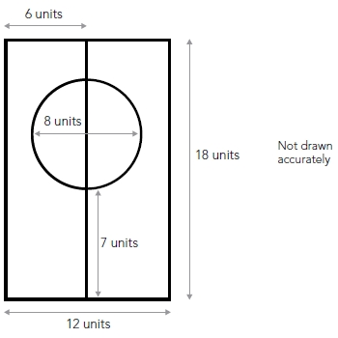
Use the correct mathematical equipment to draw accurately the flag of Greenland.
Some of the flag is drawn for you.

3 marks
Q15.
On a dice, the sum of the dots on opposite faces is always 7
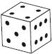
Draw dots on the three empty faces of the net so that it could fold up to make a dice.
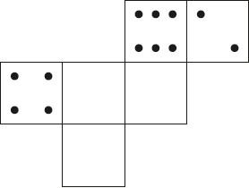
1 mark

Q16.

Here are three nets of a cube.
On each net draw one more dot so that each cube will have dots on opposite faces.

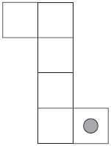
2 marks
Q17.

Look at the cuboid below.

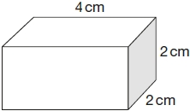
Draw two more faces to complete the net of the cuboid.

2 marks
Q18.

A cube has shaded triangles on three of its faces.

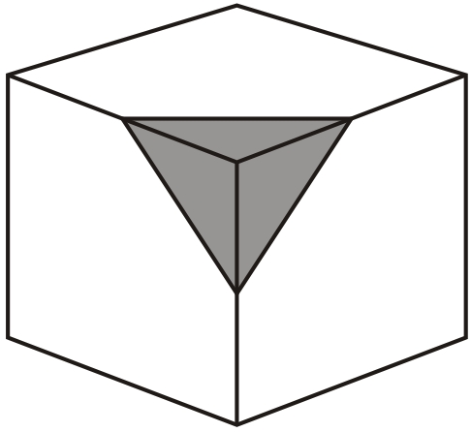
Here is the net of the cube.
Draw in the two missing shaded triangles.

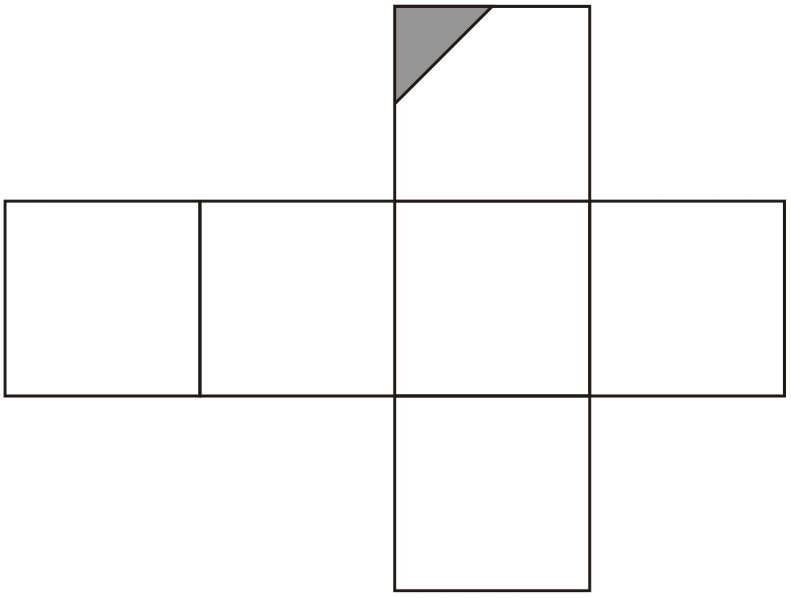
1 mark

Q19.

A cube has shaded shapes on three of its faces.

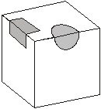
Here is a net of the cube.
Draw in the two missing shaded shapes.

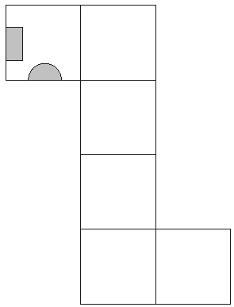
1 mark
Q20.

Here is a cube.
The cube is shaded all the way round so that the top half is grey and the bottom half is white.

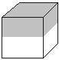Here is the net of the cube. Complete the shading.

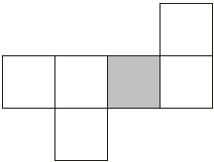
2 marks

Mark schemes
Q1.
Rectangle divided, as shown:
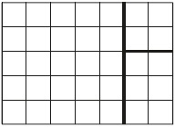
OR
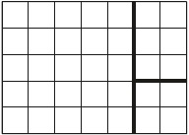
OR
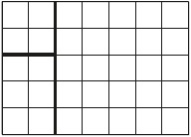
OR
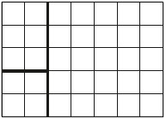
Accept slight inaccuracies in drawing provided the intention is clear.
[1]
Q2.
A quadrilateral with three acute angles, e.g.
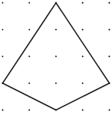
OR
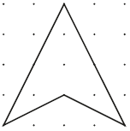
OR
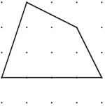
Accept inaccurate drawing provided the intention is clear.
[1]
Q3.
Diagram completed as shown:
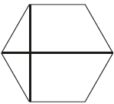
OR
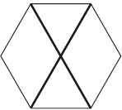
Accept slight inaccuracies in drawing, provided the intention is clear.
Diagrams may be completed in any orientation.
U1
[1]
Q4.
Completes all three rows correctly, eg:

• | rectangle | 3cm | 3cm | 15cm | 15cm
 | rhombus | 9cm | 9cm | 9cm | 9cm
 | kite | 10cm | 10cm | 8cm | 8cm

! Measures
Accept Side lengths in each row may be given in any order
Accept correct values with cm omitted eg, for the rectangle:
• 15 3 15
2
or
Completes two rows correctly
1
[2]
Q5.
(a) rhombus
Accept unambiguous abbreviations or recognisable misspellings.
1
(b) kite
Accept unambiguous abbreviations or recognisable misspellings.
1
[2]
Q6.
Two more lines drawn which intersect at a fourth vertex located
anywhere on the dotted line shown on the diagrams below, eg
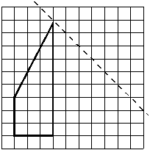
OR
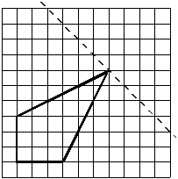
OR
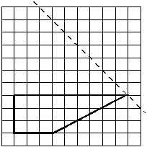
Accept slight inaccuracies in drawing provided the intention is clear.
[1]
Q7.
(a) 55°
If answers for 9a and 9b are transposed, but otherwise correct, award the mark for 9b only
1
(b) 25°
1
[2]
Q8.
132
[1]
Q9.
(a) 289
1
(b) Award TWO marks for a correct answer of 205 OR a number calculated from the answer given in (a), ie
(answer given in (a)) – 66
If the answer is incorrect, award ONE mark for evidence of an appropriate method, eg
196 – (4 × 16.5)
OR
(answer given in (a)) – (4 × 16.5)
OR
14² + 3² = 196 + 9 (Pythagoras)
Calculation need not be completed for the award of the mark.
Up to 2
[3]
Q10.

(a) Indicates
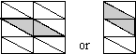
1
(b) Indicates the correct shape not shaded in part (a).
Throughout, shading or drawing need not be accurate, as long as the pupil’s intention is clear.
Accept correct shapes drawn on any grid.
Ignore the shape given in the example, or individual single triangles, shaded or drawn on any grid.
Ignore a correct shape repeated on any grid.
1
(c) Indicates 4 triangles which form a bigger triangle similar to those
forming the grid, eg:
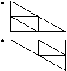
1
(d) Indicates 9 or more triangles which form a bigger triangle similar to
those forming the grid, eg:
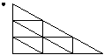
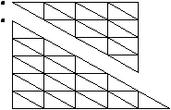
1
[4]
Q11.
11 cm
[1]
Q12.
Award TWO marks for the correct answer of 14
If the answer is incorrect, award ONE mark for evidence of appropriate
method, eg
17.5 × 4 = 70
70 ÷ 5
Accept for ONE mark 140 OR 1.4 as evidence of appropriate method.
Answer need not be obtained for the award of ONE mark.
Up to 2 (U1)
[2]

Q13.
(a) 12.5 OR 12½
1
(b) Award TWO marks for the correct answer in the range of 66 to 66.1
inclusive OR an answer based upon values obtained in 13a.
If the answer is incorrect award ONE mark for evidence of an
appropriate method, eg
• (3.14 × 5 × 5) –12.5
The calculation need not be completed for the award of the mark.
Up to 2
[3]
Q14.
Completes the drawing according to the following conditions, with a tolerance of 3 mm in each case
the circle has a diameter of 8 cm
the highest point at which the circle crosses the central vertical line is 3 cm from the top of the answer box
the lowest point at which the circle crosses the central vertical line is 7 cm from the bottom of the answer box
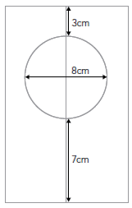
3
or
Any two of the three conditions given above are correct
2
or
Any one of the three conditions given above is correct
1
Accept flag constructed ‘upside down’
! Shading incorrect or omitted, or additional lines drawn
Condone, provided the response is unambiguous
! Compasses not used
For pupils who meet one or more of the conditions without using compasses, deduct ONE mark
[3]

Q15.
Net completed, as shown:
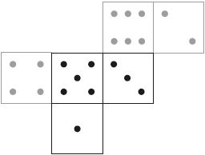
Accept unconventional arrangements of the dots, provided the intended number is clear and correct.
Accept numbers instead of dots.
[1]
Q16.
Award TWO marks for three diagrams completed as shown:
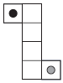
Accept alternative unambiguous indications.
If the answer is incorrect, award ONE mark for two diagrams correct.
Up to 2
U1
[2]
Q17.
(a) Rectangle (oblong) drawn in one of the correct positions as shown
in diagram below:
1
(b) Square drawn in one of the correct positions as shown in the diagram below:
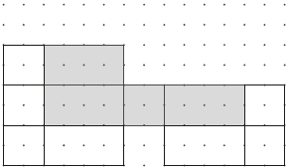
Only accept a square that is joined to the side of an adjacent rectangle (oblong).
1
[2]
Q18.
Diagram marked as shown:
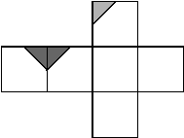
Both triangles must be correctly marked.
Accept slight inaccuracies in drawing, provided the intention is clear.
Triangles need not be shaded.
[1]
Q19.
Diagram completed as shown:
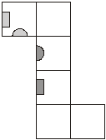
Accept: inaccuracies in drawing provided the intention is clear.
Shapes need not be shaded.
[1]

Q20.
Award TWO marks for four faces correctly shaded as shown:
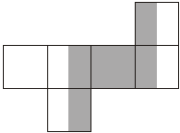
If the answer is incorrect, award ONE mark for:
• only the correct four faces marked AND at least two shaded correctly
OR
• four faces shaded correctly AND one shaded incorrectly
OR
• three faces shaded correctly AND none shaded incorrectly.
The width of each shaded rectangle is irrelevant provided the intention is clear.
Up to 2 (U1)
[2]

