 |  | Year group: 5/6 | Week beginning: 18/1/21
 |  | Key learning | Activities
Monday | English | Goodnight Mr Tom – Chapter 2  Finish reading chapter 2.  Audio recording of Chapter 2 being read is available here:  https://www.youtube.com/watch?v=XQ-ujDwgQ2o  Online version of Goodnight Mr Tom attached to last week’s email if required. | If you haven’t done so already, finish reading chapter 2 and complete your visual story map for this chapter which you started on Friday.  This week you are going to put yourselves in the shoes of either Mister Tom or Willie Beech and work towards writing a diary entry as your chosen character, sharing your thoughts, emotions and feelings of this first meeting.  Once you have chosen which character is to be your focus, we want you to compose 10 questions you would like to ask them at this point in the story if you had the opportunity to do so. Consider what a big event this is in both characters’ lives – what could you ask to find out more about how they are feeling and to understand more about their current situation?  You will be answering these questions in tomorrow’s session.
 | Maths | In this week’s learning you will:  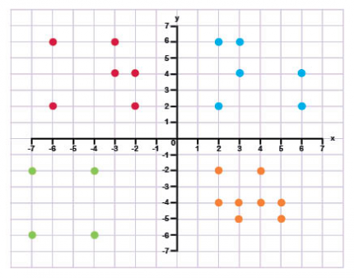  - develop your understanding of coordinates in all four quadrants, including developing skills using negative numbers  - use this understanding to draw, translate and reflect shapes on a coordinate grid.  - use this knowledge to find missing coordinates in a range of 2-D shapes in problems both with and without gridlines  Please note, if you less confident about coordinates (see above) then we would suggest you work on the activities found on the Support Sheet.  Describing coordinate positions on a grid  In today’s lesson, you will learn to describe the position of coordinates on a full coordinate grid. | Oak National Academy Key Stage 2 Maths Coordinates and shape  Lesson 1  Watch and complete activities linked to the following online lesson.  https://classroom.thenational.academy/lessons/describing-coordinate-positions-on-a-grid-6hgpat  Here are some additional questions if you would like reinforce your learning.  Four Quadrants:  https://resources.whiterosemaths.com/wp-content/uploads/2019/10/Y6-Autumn-Block-4-WO2-Four-quadrants-2019.pdf  Arithmetic Practise  This week’s focus: division. Division using 1 digit and 2 digit numbers, division of decimals and fractions.
 | Other | Spelling  words that end with the ‘shun’ sound suffix but are spelt in the following ways:  -tion -sion, -ssion, -cian  Here are the main rules:  -tion Main suffix for root words ending with –t, -te  -sion Used for root words ending in –d, -de or -se  -ssion Used for root words ending with –ss or -mit  -cian Often used when the root word is a profession e.g. electrician, musician  1. nation  2. completion  3. attention  4. intention  5. decision  6. confusion  7. collision  8. confession  9. admission  10. mathematician  Activity 1: Watch and work along with the following video which explores the different suffixes and how they are used  https://classroom.thenational.academy/lessons/to-investigate-suffixes-tion-cian-sion-ssion-6xhkje  Activity 2: Watch and work along with the following video, which reviews the spelling rules and provides different strategies to learn them. At the end of this video there is a spelling test – this could be done at the end of the week if you want to practise further.  https://classroom.thenational.academy/lessons/to-practise-and-apply-knowledge-of-suffixes-tion-cian-sion-ssion-including-test-64vk2e  It could be a good idea to work on this over the week, rather than trying to complete all in one session. Maybe test yourself on the words above at the beginning and at the end of the week – can you improve your score through practising?
Tuesday | English | Goodnight Mister Tom – Chapter 1 and 2  Answering of questions from previous session and reflection on events and emotions. | - Yesterday you composed 10 questions to ask either Mister Tom or Willie Beech. Today you are going to start the session by attempting to answer these questions, using what we have learnt from the story so far and your own interpretation and impression of the characters.  Consider your answers carefully, as these will help you get into the mind-set of the character for later in the week when you will be writing their diary entry.  - Reflecting back on all that has happened across Chapter 1 and chapter 2, identify 5 key events or moments which your character would mention if they were to write a diary entry of this first meeting? (For example, Mister Tom would almost definitely mention spotting Willie’s bruises for the first time and Willie would definitely mention his first impressions of Mister Tom’s house)  These key events will form the main focal points of your diary entry and the elements of the day you will expand upon.  - Your final activity for today is complete a zone of relevance for your chosen character, attached to the bottom of this plan. This is an activity you have completed numerous times before in school, so should be familiar with.  Once you have added the words onto the zone, can you add 5 more of your own?  Which of these words do you think you will use in your diary? Why?
 | Maths | Translating simple shapes  In today’s lesson, you will learn to describe translation of coordinates and shapes and then translate shapes on a coordinate grid. | Oak National Academy Key Stage 2 Maths Coordinates and shape  Lesson 2  Watch and complete activities linked to the following online lesson.  https://classroom.thenational.academy/lessons/translating-simple-shapes-6hjpat  Here are some additional questions if you would like reinforce your learning.  Translations  https://resources.whiterosemaths.com/wp-content/uploads/2019/10/Y6-Autumn-Block-4-WO3-Translations-2019.pdf  Arithmetic Practise  This week’s focus: division. Division using 1 digit and 2 digit numbers, division of decimals and fractions.
 | History | Evacuation  Have a look at the attached document ‘Accounts of Evacuation.’ This contains 6 accounts from people who were evacuated during the Second World War. Today we want you to pick just one of these accounts.  Read your chosen account carefully.  - Underline any words or phrases which you are unsure about. Spend some time finding out definitions for these words or phrases as this will help with your understanding of the text and the experiences of the author.  Have a go at answering the following questions, reflecting upon what you have read:  - Where did they have to move to?  - Who were they living with? Were they welcoming?  - Do they share any positive experiences?  - Do they share any negative experiences?  - Overall, was evacuation a positive or negative experience for them? How do you know?  - What does this account teach you about evacuation?  Your final challenge is to produce a visual representation of this evacuee’s experiences of evacuation.  This should be a page of pictures and key words which capture what they shared in their account.
Wednesday | English | Goodnight Mister Tom – Chapter 1 and 2  Writing a diary entry as either Mister Tom or Willie Beech. | Today you are going to begin to write your diary entry as either Mister Tom or Willie Beech – sharing your thoughts, experiences and emotions of the day of Willie’s arrival.  Try to get yourself into character and into the mind-set of your chosen character – how do they speak? What emotions might they be feeling? How will they react to what happened?  If you think it would help you, spend 10 minutes putting together a quick plan for what you are going to write, using your 5 key events from the previous session to structure your writing.
 | Maths | Reflecting simple shapes  In today’s lesson, you will describe reflections and reflect shapes on a coordinate grid. | Oak National Academy Key Stage 2 Maths Coordinates and shape  Lesson 3  Watch and complete activities linked to the following online lesson.  https://classroom.thenational.academy/lessons/reflecting-simple-shapes-6mu3ec  Here are some additional questions if you would like reinforce your learning.  Reflections  https://resources.whiterosemaths.com/wp-content/uploads/2019/10/Y6-Autumn-Block-4-WO4-Reflections-2019.pdf  Arithmetic Practise  This week’s focus: division. Division using 1 digit and 2 digit numbers, division of decimals and fractions.
 | History | Evacuation  Today you are going to go back to the ‘Accounts of Evacuation’ and pick a different account. You now need to follow through the same activities as yesterday, further developing your understanding of what people experienced when evacuated from their home.  Read your chosen account carefully.  - Underline any words or phrases which you are unsure what they might mean. Spend some time finding out definitions for these words or phrases as this will help with your understanding of the text and the experiences of the author.  Have a go at answering the following questions, reflecting upon what you have read:  - Where did they have to move to?  - Who were they living with? Were they welcoming?  - Do they share any positive experiences?  - Do they share any negative experiences?  - Overall, was evacuation a positive or negative experience for them? How do you know?  - What does this account teach you about evacuation?  Your final challenge is again to produce a visual representation of this evacuee’s experiences of evacuation.  This should be a page of pictures and key words which capture what they shared in their account. Or you could find a different way to represent their experiences if you want to do so.
Thursday | English | Goodnight Mister Tom – Chapter 1 and 2  Writing a diary entry as either Mister Tom or Willie Beech. | Today your job is to finish writing your diary entry which you started in yesterday’s session. Before you carry on, ensure you go back and read through what you wrote yesterday.  If you have time, once you have finished, go back through your diary entry and edit and improve  - Have you managed to capture the voice of your character?  - Have you expanded on events with emotional response?  - Have you used a range of adjectives and descriptive techniques?  - Have you used full stops and capital letters accurately?  You could now illustrate your diary, taking elements from the two chapters we have read to create images to support and decorate your diary entry.
 | Maths | Solving practical coordinate problems (Part 1)  In today’s lesson, you will look for general rules relating to coordinates and then work on finding missing coordinates. | Oak National Academy Key Stage 2 Maths Coordinates and shape  Lesson 4  Watch and complete activities linked to the following online lesson.  https://classroom.thenational.academy/lessons/solving-practical-coordinate-problems-part-1-c9h3ec  Arithmetic Practise  This week’s focus: division. Division using 1 digit and 2 digit numbers, division of decimals and fractions.
 | History | Evacuation  Today we are going to use a different source of information to expand our understanding about what it was like to be evacuated. The following link will provide you with various audio accounts and news reports from 1939:  https://www.bbc.co.uk/teach/school-radio/history-ks2-world-war-2-clips-ww2-evacuation-index/zvs3scw  Spend some time exploring and listening to these accounts.  Have a go at answering the following questions in response:  - What do we learn from these accounts about evacuation?  - Do they paint a positive or negative picture about evacuation?  - Why might they not tell the full story of what was being experienced?  - Are they more or less reliable than the written accounts we read yesterday?  - Why do you think this?  If you were able to speak to someone who was evacuated during the Second World War, what questions would you ask them to find out more about their experience?
Friday | English | Goodnight Mister Tom – Chapter 1 and 2  Writing a diary entry as either Mister Tom or Willie Beech. | Over this week you have written a diary entry as either Mister Tom or Willie Beech.  Today we want you to swap.  Today we want you to write an excerpt (short extract) from the diary of which ever character you did not write your diary from this week.  We want you to focus on describing that first moment when Mister Tom and Willie Beech meet each other – sharing first impressions and emotions.  This doesn’t need to be pages and pages. Quality over quantity. It is time to change shoes and get in the mind-set of a different character.  Consider carefully how you are going to capture the huge emotions of this first meetings through your choice of language and sentence structure.
 | Maths | Solving practical coordinate problems (Part 2)  In today’s lesson, you will use the general rules that we learnt in lesson four of this unit to solve more complex problems involving coordinates. | Oak National Academy Key Stage 2 Maths Coordinates and shape  Lesson 5  Watch and complete activities linked to the following online lesson.  https://classroom.thenational.academy/lessons/solving-practical-coordinate-problems-part-2-6hh34e  Arithmetic Practise  This week’s focus: division. Division using 1 digit and 2 digit numbers, division of decimals and fractions.
 | Other | Art/Geography – Little Weirwould  In chapter 2 of Goodnight Mister Tom, we find out that the village which Willie has been brought to is called Little Weirwould.  Pages 19-22 give us a brief description of the layout of some of the village. Carefully read these pages through again and note down any details or features which are mentioned. Try to also take note of where everything mentioned is in relation to everything else and any description which is used (for example – row of small, thatched, cottages at the top of the hill)  Using the information, you have gathered, have a go at drawing out an illustrated and annotated map of the places we have been introduced to so far in Little Weirwould.  This is an example of a map someone has drawn for Hogsmeade in the Harry Potter stories:  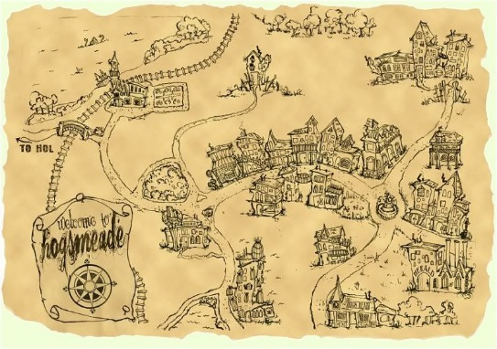
Other online learning links
 | History | Evacuation Propaganda Poster  Many families were reluctant to send their children away during the war as they did not know how long they would be apart for. To try and persuade them that it was the safest thing to do, posters were put up designed to convince them it was the right decision to make.  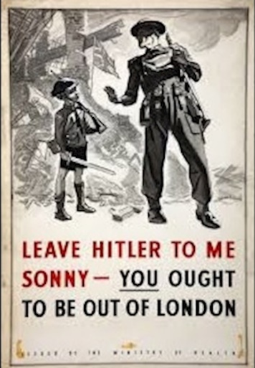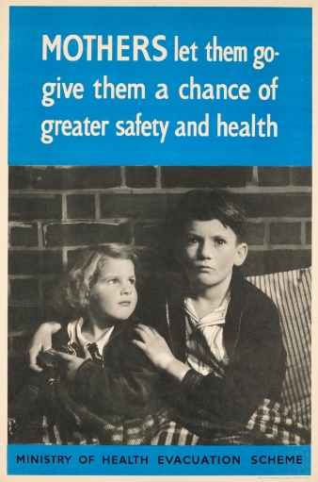  Have a go at designing a poster which would persuade parents to evacuate their children away from danger in the cities to the safety of the countryside.
 | Computing | Have an explore of the coding platform Scratch.  This is a really accessible and easy to use tool to create animations, games stories etc. It is a great starting point if you are dreaming of a career in game design.  Click on the link (https://scratch.mit.edu/ ) and then click the start creating button. This will take you to a screen where you will be presented with a step-by-step walk through guide as to how to get going on creating an animation. Or ignore this video and explore it for yourself!
 | Maths | Have a go at some of these online games, practising your understanding of coordinates.  https://www.topmarks.co.uk/Search.aspx?q=coordinates

Zone of relevance
Place the following words onto the zone of relevance for either Mister Tom or Willie Beech. The closer to the centre you place the word, the more relevant it is to that character. The further away from the centre, the less relevant it is.
Bewildered Excited Upset Frightened Annoyed Frustrated Worried Confused Pleased Anxious
(remember, it is important you fully understand the meaning of a word before you can place it onto the zone of relevance)

